ULTIMATE-MICRO.com
-Thank you Sean, James, and Michael

-donations for garage sale items

-KFest committee

-Members of the community

-and you

ULTIMATE-MICRO.com
KFEST Refreshments

UM Is Offering Espresso, Coffee, and Tea.
Room 133

UM Travel Mugs: $10 Unlimited Refills.

We Ask For A $1 Donation.

ULTIMATE-MICRO.com
Year In Review
- Official Launch of Ultimate-Micro.com
UM logo to more easily identify
collaborative projects.
ULTIMATE-MICRO.com
Year In Review

- Always looking to work with people or help market your project.
- Anyone looking to collaborate, please contact us.
- Dagen Brock – MiniMemoryTester
https://github.com/digarok/mmt

ULTIMATE-MICRO.com
Year In Review

- UA2 Launch of Support Forums and New Store.
Manuals – Software – Support
- Apple II Forever Award
ULTIMATE-MICRO.com
Year In Review
- UM Completed and Released Projects:
TWGS v1.0 SO v1 and V2
8Meg RAM Card v2 No-Slot Clock
32k Cache Card v7 A2DiskContoller v1.1
Universal PSU Kit Mockingboard
DuoDisk Cable RAMWorks IIII Kit
RAMWorks and RAMFactor Expanders
IIgs ROM0 to ROM1 Adapter
SOJ to DIP Adapter
ULTIMATE-MICRO.com
Year In Review

- Project Review Team Partners:

Chris Torrence: Assembly Lines
https://goo.gl/Vxy3VY

Joe Strosnider: Joe's Computer Museum
https://goo.gl/ZCl3Ia

ULTIMATE-MICRO.com
KFEST Releases
- RAMWorks IIII Kit
- Universal PSU Kit
- Apple Confidential Files!
Big thank to Javier Rivera for his help!
Anonymous Donor.
ReActiveMicro.com Downloads:
https://goo.gl/ITRuxz
News And Updates
- Pi v6.5 Project
- Pi v4.4b Re-released
- IDEA2c Drive Collaborators
- PSU Enclosures
- EDD4+ v1.2 In Store
- Raffel

News
- UM Completed and Released Projects:
TWGS v1.0 No-Slot Clock SO v1 and V2
Mockingboard DuoDisk Cable RAMWorks IIII Kit
8Meg RAM Card v2 32k Cache Card v7
A2DiskContoller v1.1 Universal PSU Kit
RAMWorks and RAMFactor Expanders
IIgs ROM0 to ROM1 Adapter
SOJ to DIP Adapter
1
News
- Standard Features on ALL Projects
Gold Fingers
Tantalum and Ceramic Power Filtering Capacitors
Resettable Fuse
Power LED
- Moved from 1206 to 603 Parts on ALL Projects
2
News
- Schematics Released
CV Tech 8 Meg RAM Card
RAMWorks III
RAMWorks III 2 Meg Expander
- Via and Track Sizing Guide
3
News
New Wiki
www.ReActiveMicro.com/wiki
Like apple2faq.com, but more open.
- New Store / Website
store.ReActiveMicro.com
4
KFEST Release!
- Project Release:
Phasor

- Raffle:
MicroDrive/Turbo
Phasor

5
News
- Open Apple Interview
Pod Cast #55
- Moved to KiCAD
- Milestone Projects:
Universal PSU Kit
No-Slot Clock v1.3
6 RAMWorks IIII Kit
Milestone Project: Universal PSU Kit
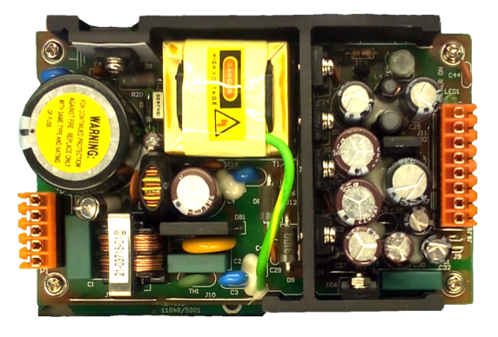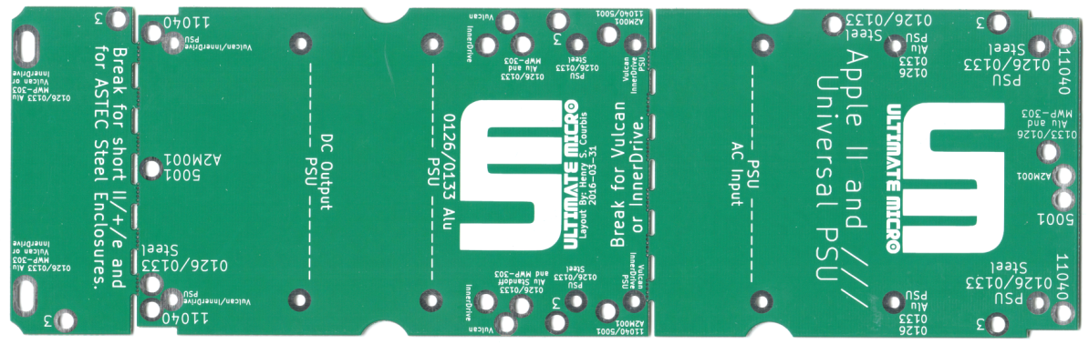
Allows A Known Good Starting Point For Testing
No “Perfect” Solution Was Available
Separate Session About All The Above Points
Milestone Project: No-Slot Clock v1.3
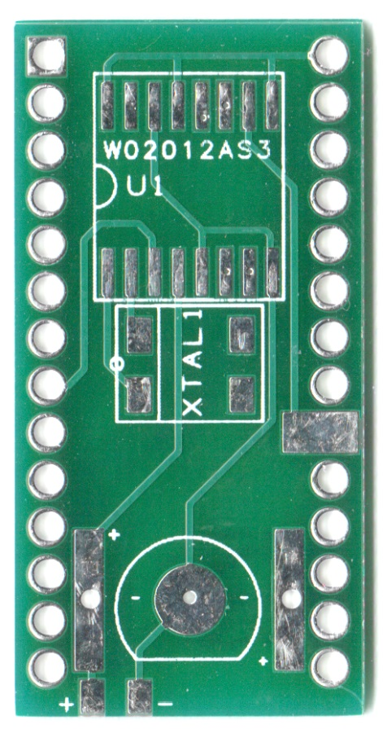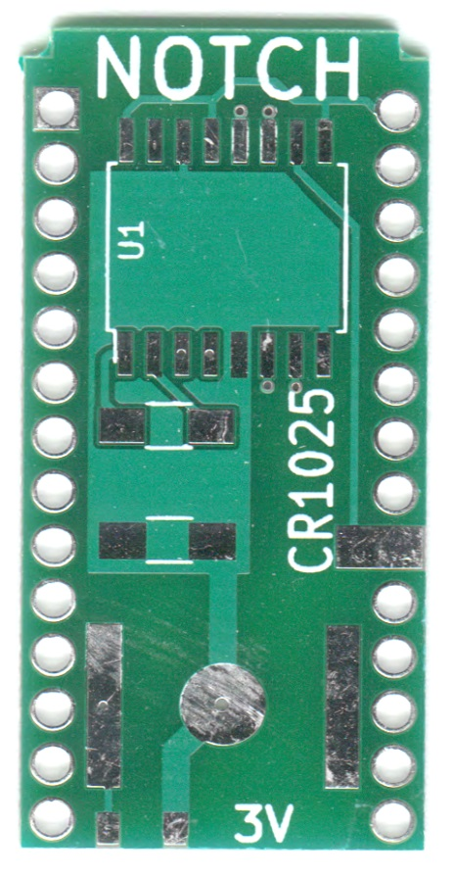
Milestone Project: RAMWorks IIII Kit
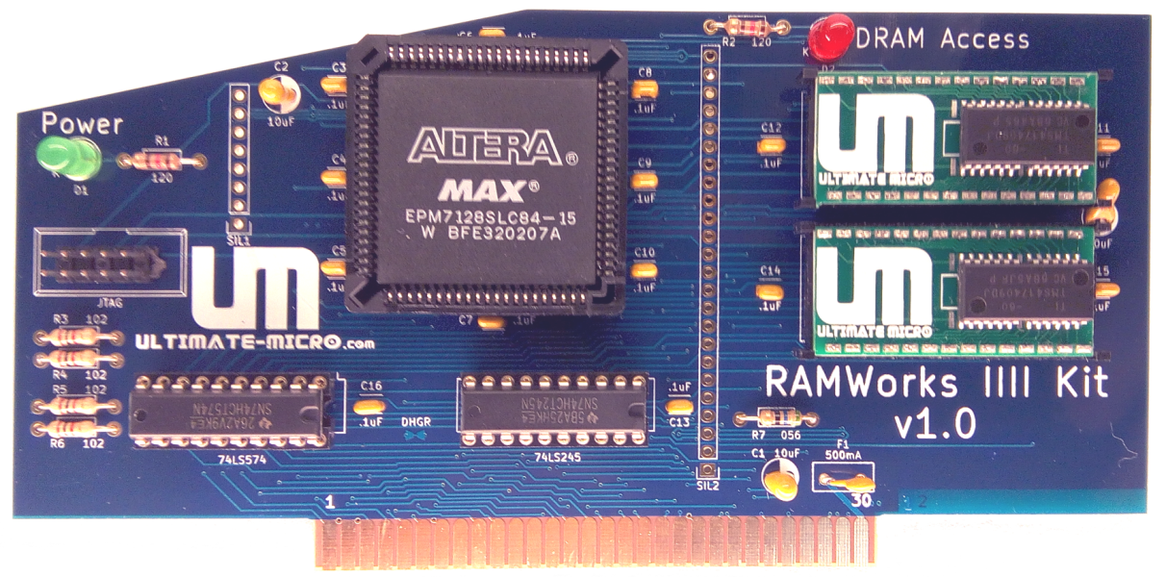
Apple II First: Most Dense DRAM Ever Used In Apple IIe
Kit Designed For KFEST / SolderFEST
Circuit Can Be Reused In Other Projects
New Issues Encountered
- Socket Stretch
All New Adapters Designed With DIP Plugs (.015 mil pins)
Apple Used Low Quality Sockets
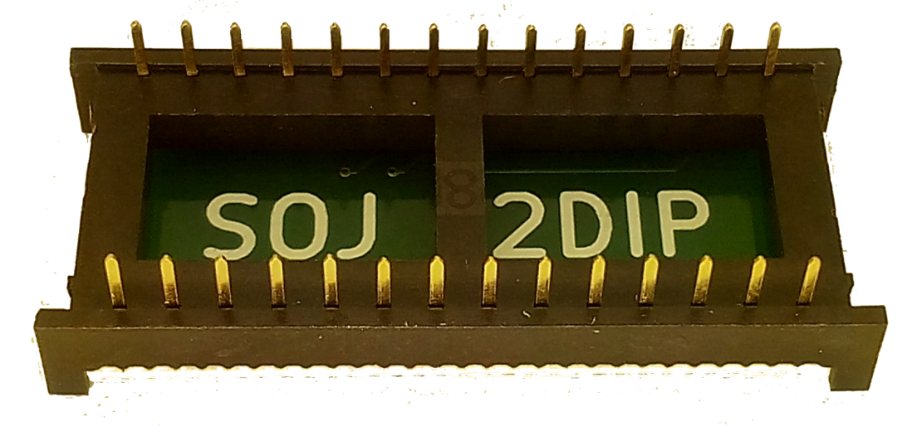
New Issues Encountered
- A2Heaven’s RAMWorks VGA
Found And Resolved Issues In Platinum IIe
Issue Confirmed Fixed By Joe Strosnider
Plamen Vaysilov Including Mod On All New Boards

Project Plan 2016-2017

- Universal HDMI Adapter
- TransWarp v2
- IIe Kit
- RAMWorks IV (16Megs)
- RAMWorks Compatible RGB Card
Project Plan 2016-2017

- 3.5” Disk Controller (SWIM IC)
- Apple II/+ ROM/Language Combo
- Phasor v2
- Amiga / Commodore
- Open Source and Unlocked
Project Collaboration

- Anyone looking to collaborate, please contact me.
- TransWarp v2 – Geoff Body
- IIe Kit - Britt Dodd
- Phasor v2 – Tom Arnold
- Amiga PSU - John Swiderski
Project Collaboration

- Able To Help Review Projects And Layouts
- Recommend ICs And Find Bulk Sources
- Diagnose Issues And Find Solutions
- Help Bring Projects To Market

Project Collaboration

- Justin Scott
Triple-Trouble & Interface Two
- Xander Mass
Firmware Development Card

Thanks!
Anthony Martino, John Morris, Geoff Body, Tom Arnold
Glenn Jones, Plamen Vaysilov, Dagen Brock,
Chris Torrence, Joe Strosnider, David Ramsey
Gabriele Gorla, My Legs For Supporting Me
My Fingers - I Can Always Count On Them
My Arms For Always Being By My Side
Xander Mass, My Hands For Helping Me Hold On
Javier Rivera, Everyone I Forgot To List
Apple II Community - Woz
KFEST Committee For Their Time And Efforts To Make KFEST Happen!

